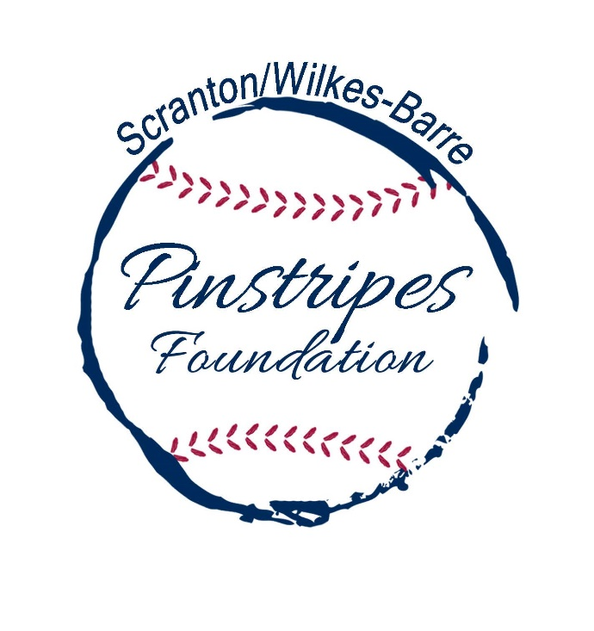
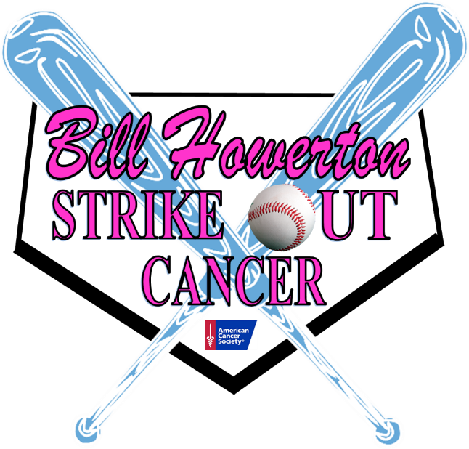

Baseball Coaches Clinic

The SWB Pinstripes Foundation and the Bill Howerton Strike Out Cancer Committee will host a Baseball Coaches Clinic to benefit the Bill Howerton Strike Out Cancer Fund. Our guest speakers will include high school and college coaches as well as professional scouts and other baseball personnel. There will be seminars and raffle baskets. All proceeds from funds raised by the SWB Pinstripes Foundation will benefit the Bill Howerton Strike Out Cancer Fund.
Please attend, discuss the game and contribute to a great cause.

When: Sunday, February 25, 2018
Time: 4:00pm-8:00pm
Where: PNC Field
Cost: $25

Preregistration Raffle: You do not have to preregister. You can show up the evening of the 25th. However, we would like to secure a rough head count. If you email us that you will be attending the clinic, your name will automatically be entered into a raffle for a $1 00 Target gift card. Email “I will attend the Howerton Coaches Clinic” to info@electriccitybaseball.com.

HOPE TO SEE YOU THERE!

